**Api Development**

Here, we have layers. We have one solution for many projects. When we name our controllers in Api we normally add “s” to the end of the name. 

And in the controller we specify the followings 🡪



**Localhost:portNumber/api/Students** for instance.

It is also important to specify the request with an attribute 🡪



In api applications, our route doesn’t include the action name, instead it includes the name that is written in the Http attribute for example here it will be **Localhost:portNumber/api/Students/list**

If we don’t have the name for the attribute then others actions must have the name otherwise there will be a conflict.

Here our controllers inherit from ControllerBase. We don’t need to inherit from the Controller class since we don’t use views here.



**Layers**

In api apps, we have a repository , DomainModels and Api project itself 🡪

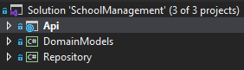

DomainModels and Repository are class libraries. In the DomainModels we have our Models and Dtos (data transfer objects).

In the Repository, we have got our DAL which means we also need the following packages: EntityFrameworkCore and EntityFramework. SqlServer. EntityFrameworkCore is to inherit from DbContext and EntityFramework.SqlServer is for migrations. We will place the migrations folder in the repository project!

In order for migrations to be in the Repository project we need to explicitly tell it in the Startup 🡪

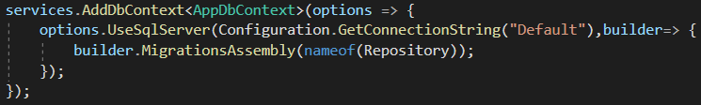

**Mapper**

We place our mappers in the repository project. We also need to add AutoMapper package to the repository project so that we can do the followings 🡪

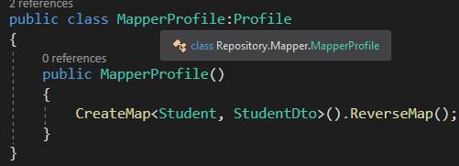

The naming conventions is to add “Profile” to the end of our mapper name. we inherit from Profile and in the constructor we create our mappers. The first object is the source and the second one is the destination.

In order to use our mappers, in the api project we need the AutoMapper.Extensions.Microsoft.DependencyInjection package so that we can inject our mapper to controllers.



Also in the Startup we need to add the following 🡪

